**Name :- Mohini Pramod Badhe.**

**Roll No :- 05**

**Practical :- 01**

**Practical Name :- Set up a GitHub account and send an email a message to friend telling to your friend about the account**

---------------------------------------------------------------------------------------------------------------------------------------------------------

**Create a GitHub account:-**

**if you do not have a GitHub account, here’s how to create one.**

**1.Open https://github.com in a web browser and select the sign up.**



**2. Enter the email address**

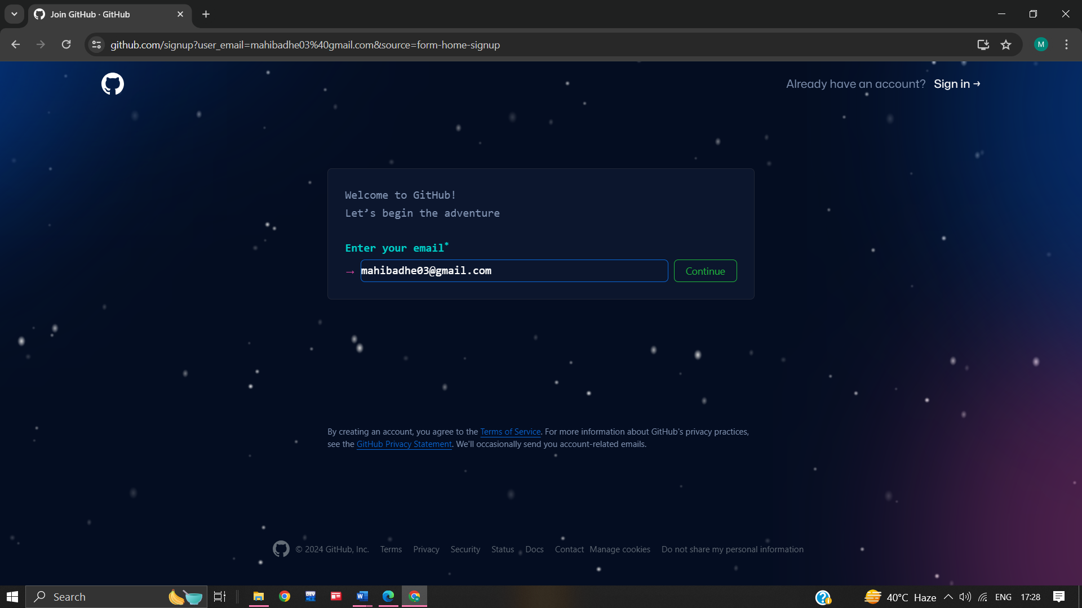

3. **Create a password for your new GitHub account, and Enter a username ,too. Next choose whether you want to receive update and announcements via email,and then selwct continue.**

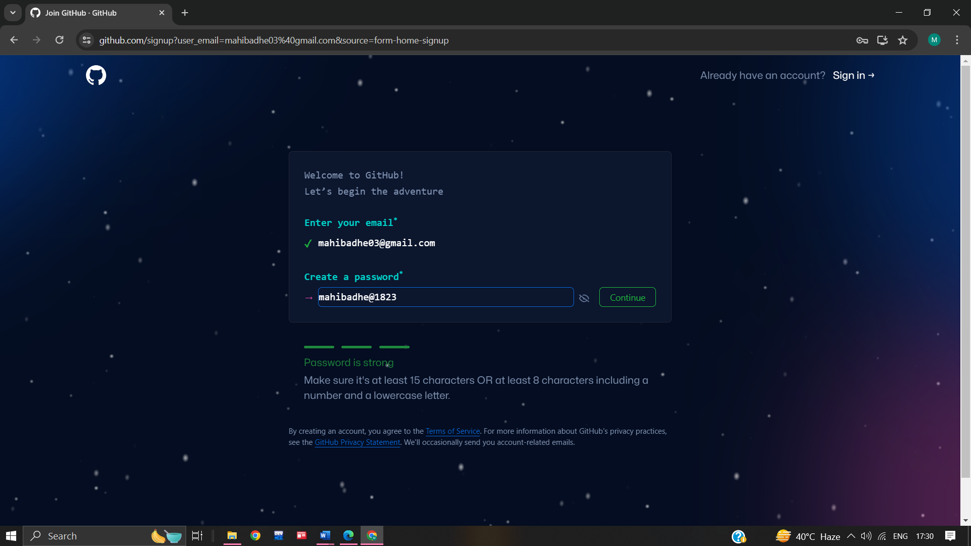

**4. Enter the username**

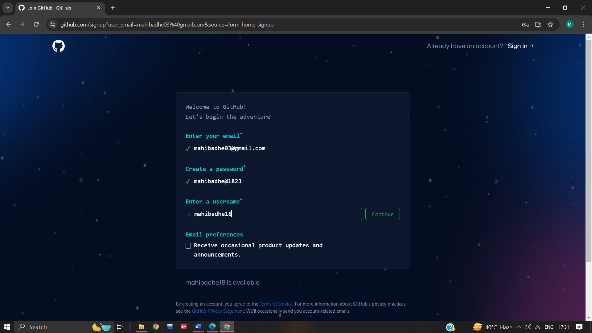

**5. Would you like to receive product updates and announcements via email? Type "y" for yes or "n" for no**

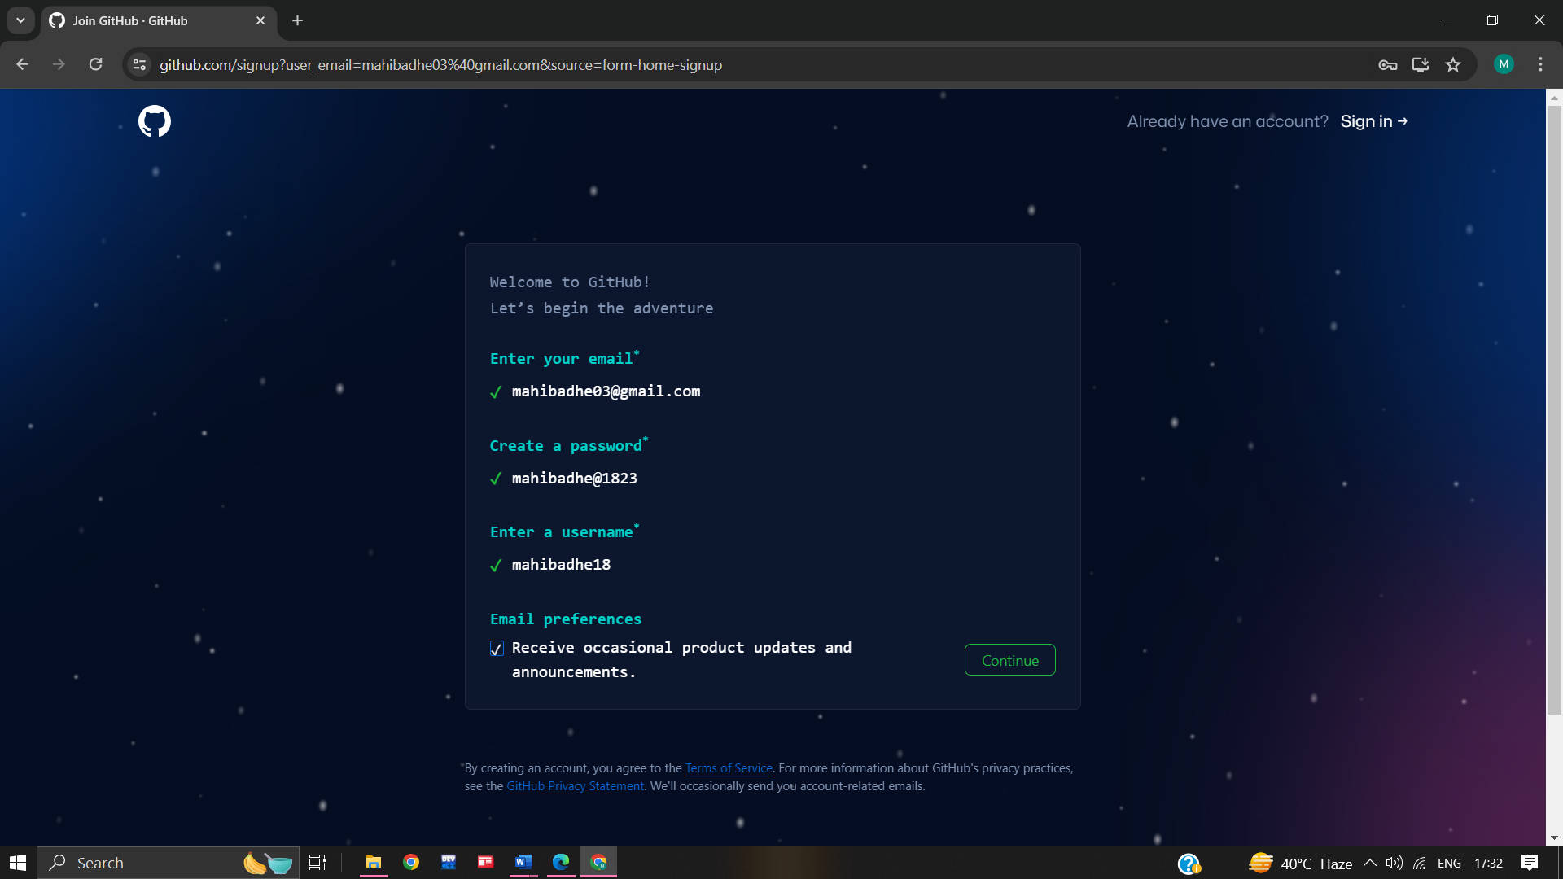

**6. Verify your account by solving a puzzle .select the start puzzle button to do so, and then follow then follow the prompts.**

**7. After you verify your account, select the create account button.**

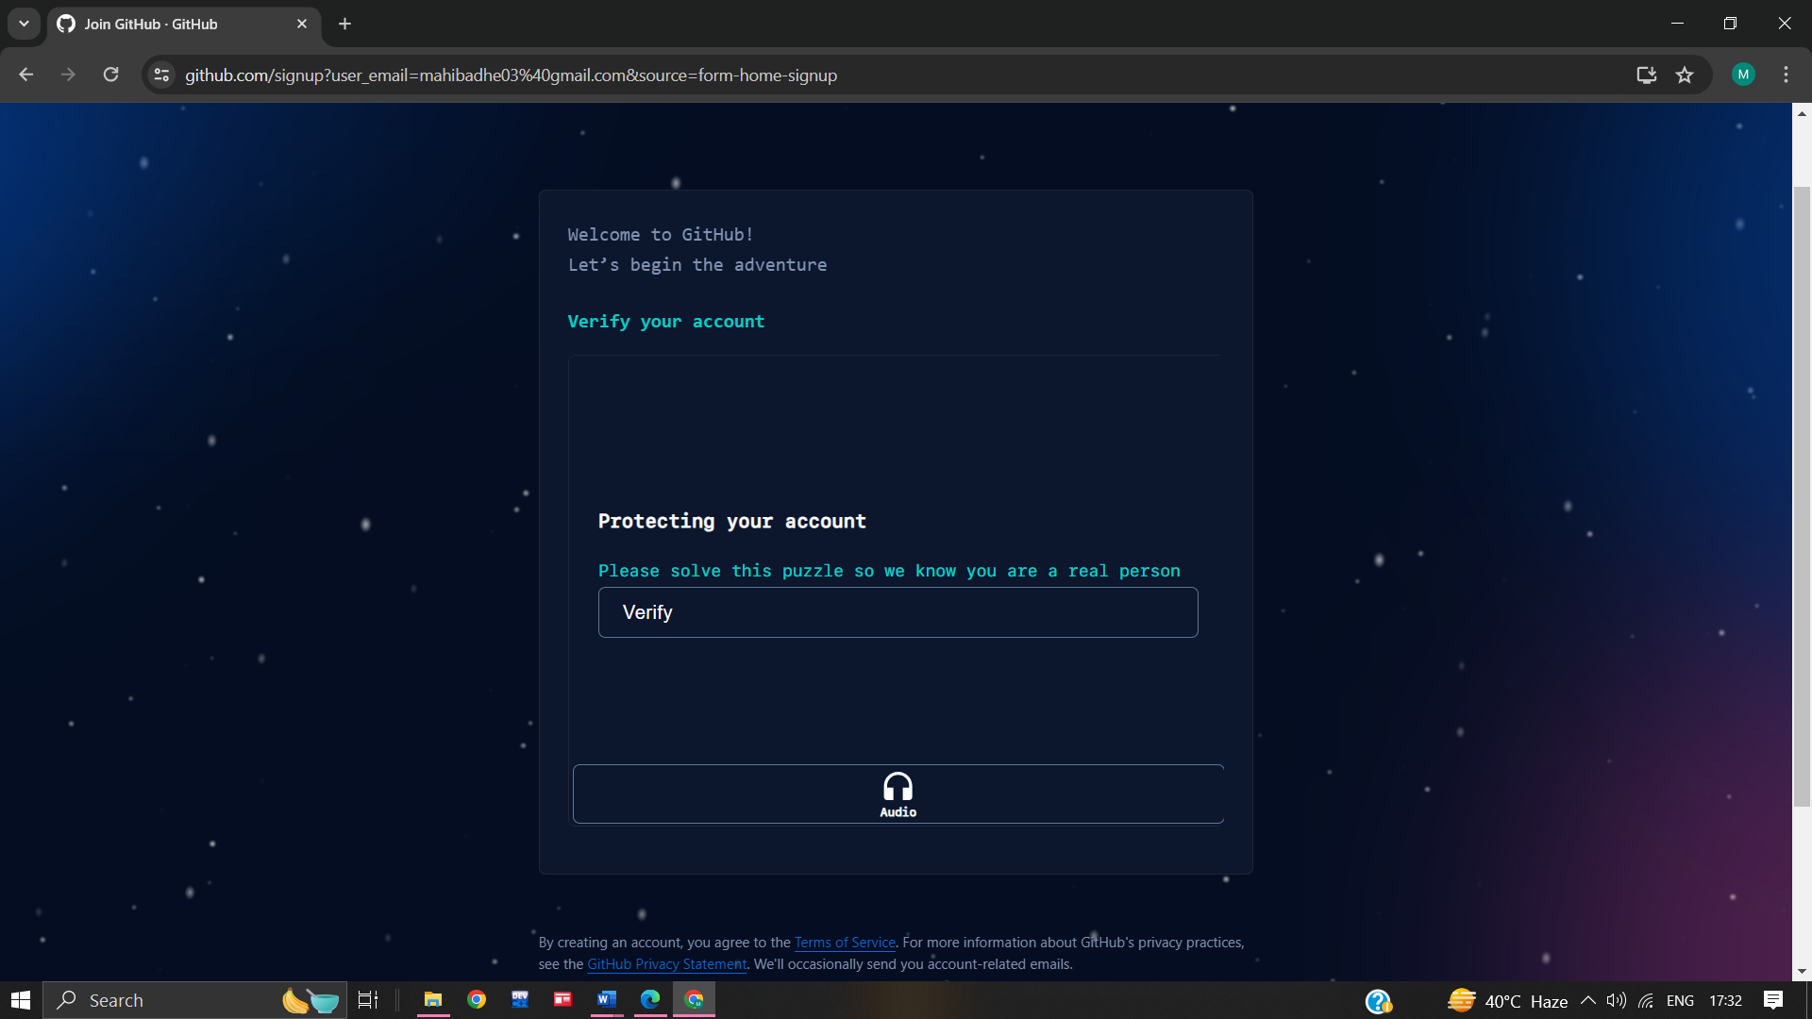

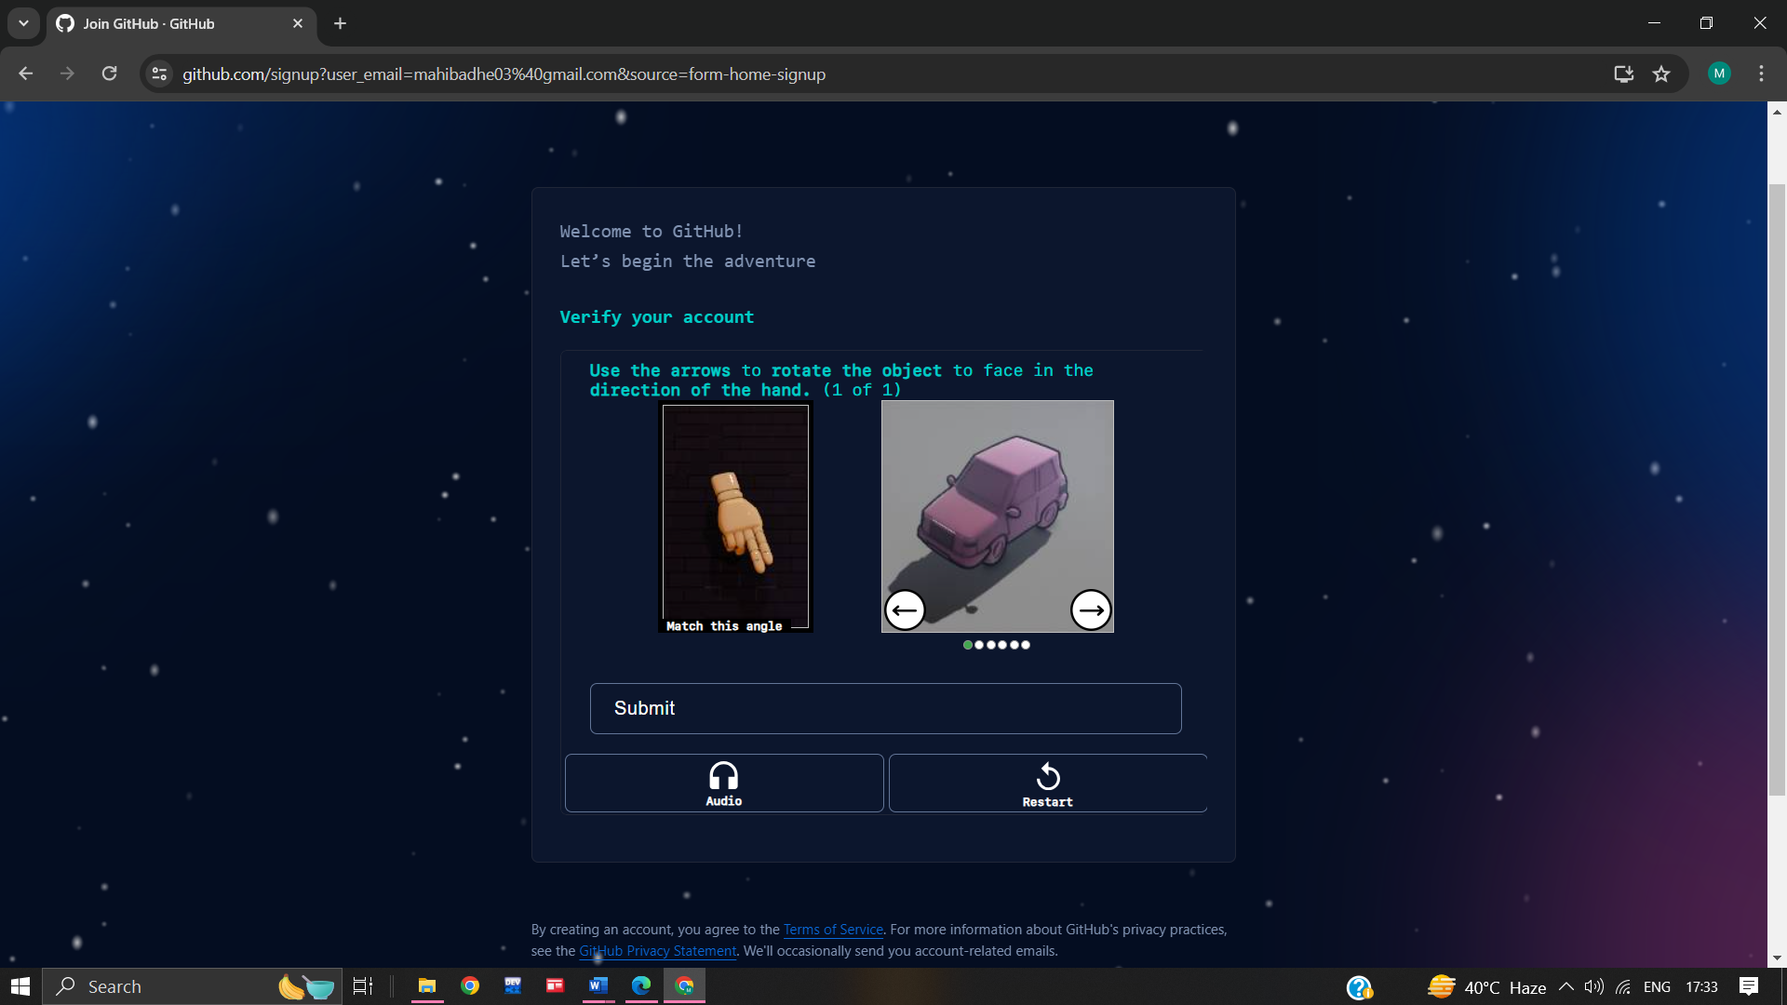

**8. Next, GitHub send a launch code to your email address. Type that launch code in the enter code dialog , and then press enter.**

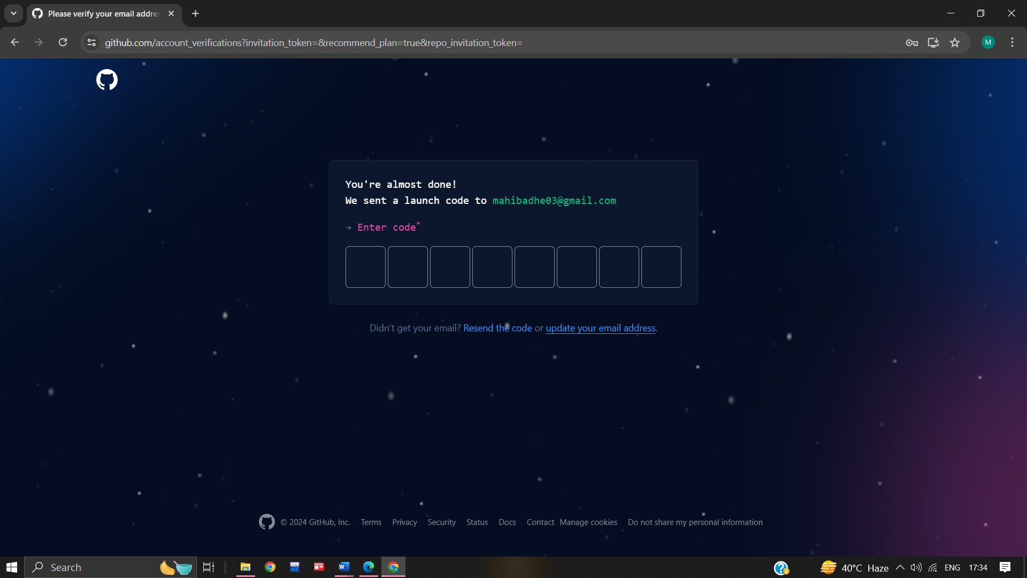

**9. GitHub asks you some questions to help tailor your experience. choose the answer that apply to you in the following dialogs:**

**\* How many team members will be working with you?**

**\* What specific feature are you interested in using?**

**10. On the where team collaborate and ship screen,you can choose whether you want to use the free account or the team account. To choose the free account ,select the skip personalization button. GitHub opens a personalized page in your browser.**

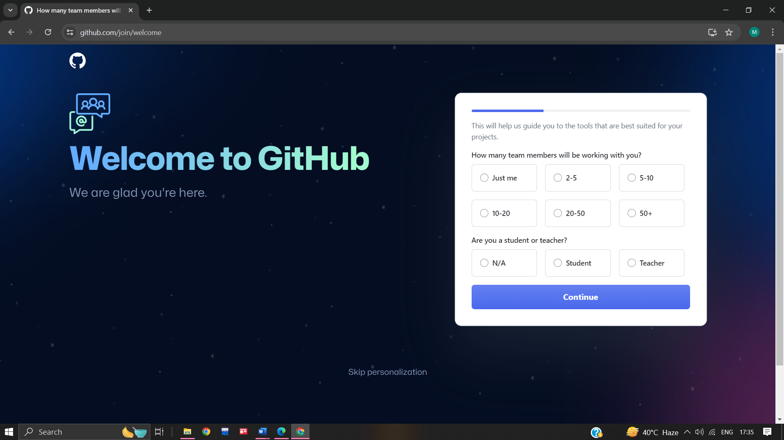

**Congratulations! You’ve successfully created your GitHub account.**

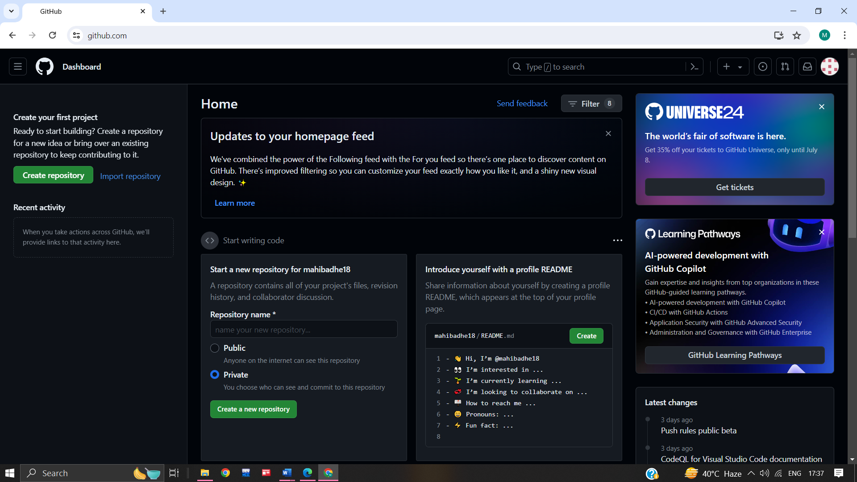

* **Paste the screen shots of email which you had send to your friend through GitHub.**

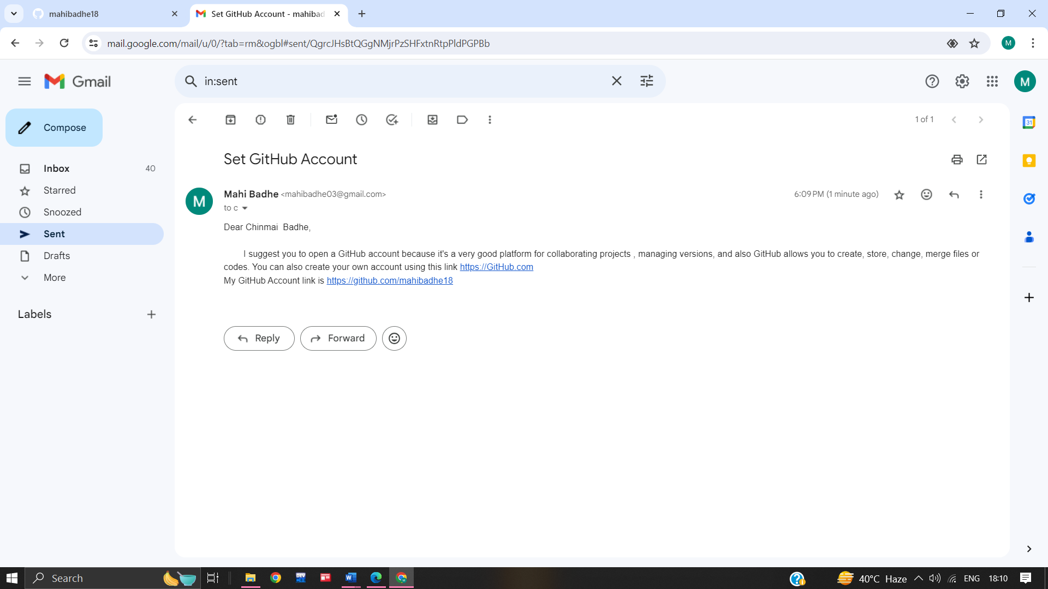

**Name :- Mohini Pramod Badhe.**

**Roll No :- 05**

**Practical :- 02**

**Practical Name :- Clone the repository at**

**https://github.com/mahibadhe18/KBCNMU.git**

---------------------------------------------------------------------------------------------------------------------------------------------------------

MOHINI@LAPTOP-J8VNJ4IR MINGW64 /c/mohini

$ git --version

git version 2.42.0.windows.2

MOHINI@LAPTOP-J8VNJ4IR MINGW64 /c/mohini

$ git help

usage: git [-v | --version] [-h | --help] [-C <path>] [-c <name>=<value>]

[--exec-path[=<path>]] [--html-path] [--man-path] [--info-path]

[-p | --paginate | -P | --no-pager] [--no-replace-objects] [--bare]

[--git-dir=<path>] [--work-tree=<path>] [--namespace=<name>]

[--config-env=<name>=<envvar>] <command> [<args>]

These are common Git commands used in various situations:

start a working area (see also: git help tutorial)

clone Clone a repository into a new directory

init Create an empty Git repository or reinitialize an existing one

work on the current change (see also: git help everyday)

add Add file contents to the index

mv Move or rename a file, a directory, or a symlink

restore Restore working tree files

rm Remove files from the working tree and from the index

examine the history and state (see also: git help revisions)

bisect Use binary search to find the commit that introduced a bug

diff Show changes between commits, commit and working tree, etc

grep Print lines matching a pattern

log Show commit logs

show Show various types of objects

status Show the working tree status

grow, mark and tweak your common history

branch List, create, or delete branches

commit Record changes to the repository

merge Join two or more development histories together

rebase Reapply commits on top of another base tip

reset Reset current HEAD to the specified state

switch Switch branches

tag Create, list, delete or verify a tag object signed with GPG

collaborate (see also: git help workflows)

fetch Download objects and refs from another repository

pull Fetch from and integrate with another repository or a local branch

push Update remote refs along with associated objects

'git help -a' and 'git help -g' list available subcommands and some

concept guides. See 'git help <command>' or 'git help <concept>'

to read about a specific subcommand or concept.

See 'git help git' for an overview of the system.

MOHINI@LAPTOP-J8VNJ4IR MINGW64 /c/mohini

$ git clone https://github.com/mahibadhe18/KBCNMUU.git

Cloning into 'KBCNMUU'...

remote: Enumerating objects: 4, done.

remote: Counting objects: 100% (4/4), done.

remote: Compressing objects: 100% (3/3), done.

remote: Total 4 (delta 0), reused 0 (delta 0), pack-reused 0

Receiving objects: 100% (4/4), done.

**1.Create Repositories**

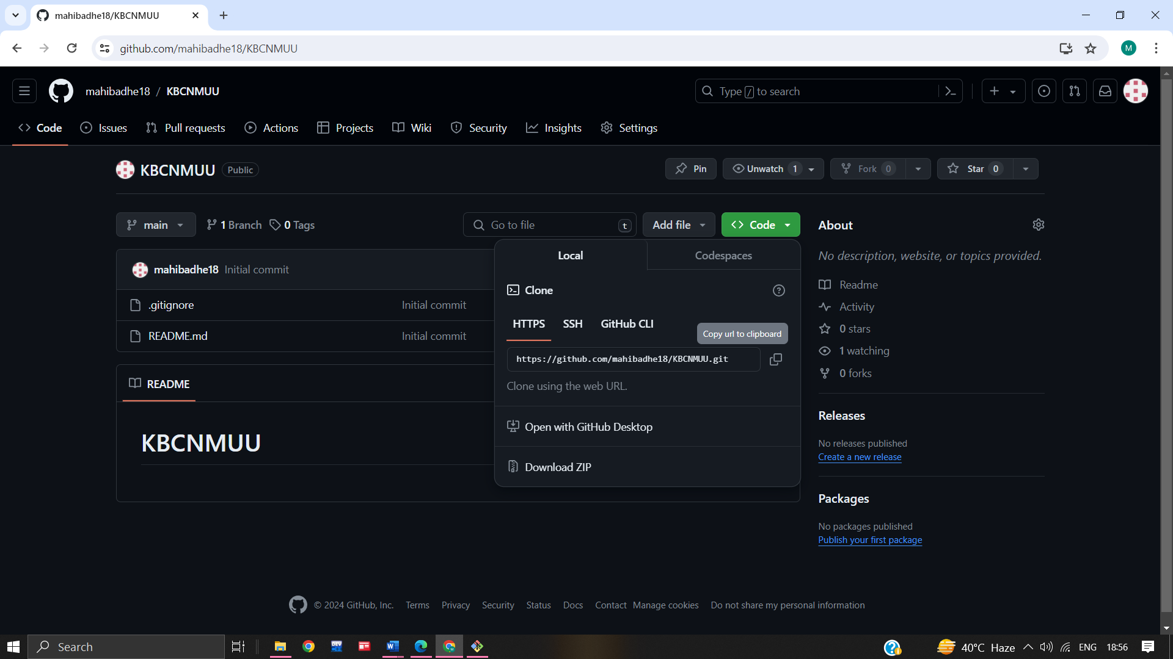

**2.After cloning**

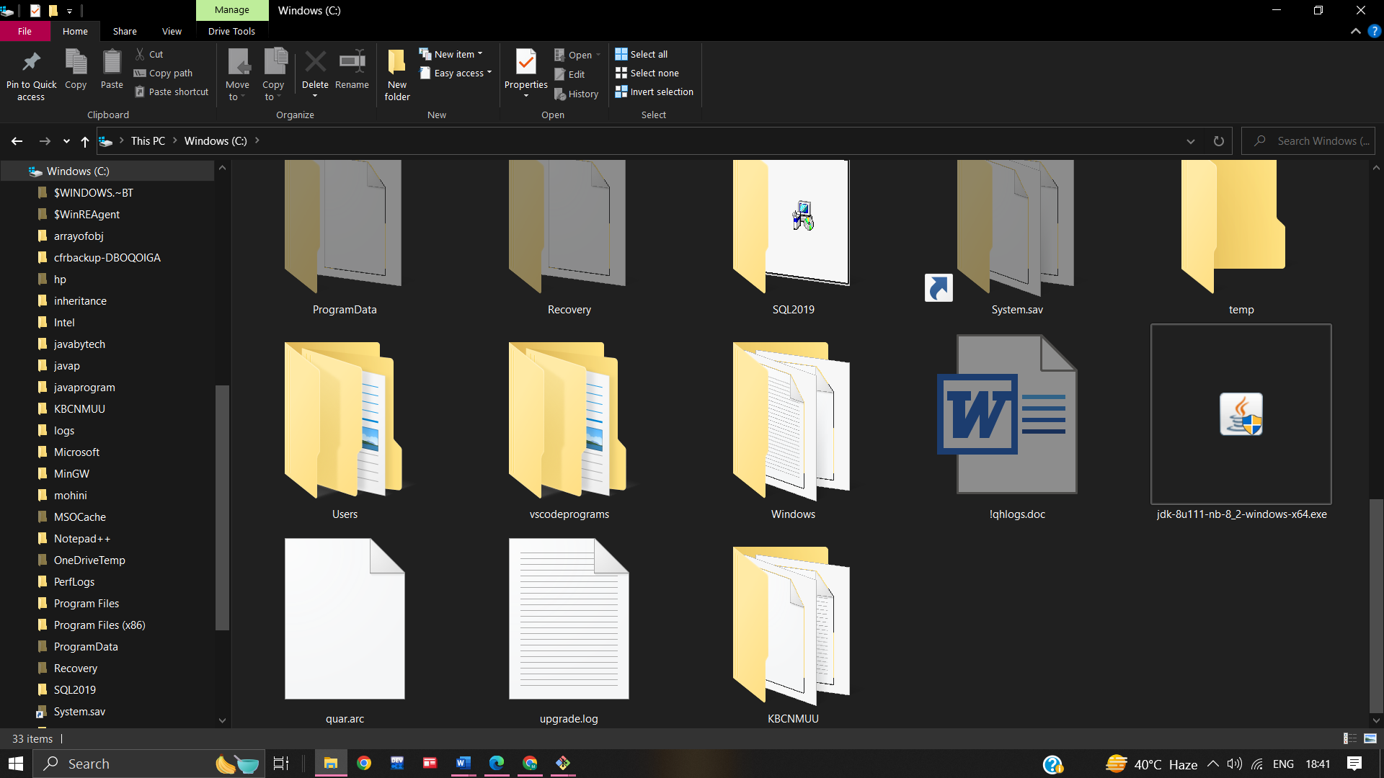

**Name :- Mohini Pramod Badhe.**

**Roll No :- 05**

**Practical :- 03**

**Practical Name :-Use git add to add the file to the repository use git commit to commit your change.**

------------------------------------------------------------------------------------------------------------------------------------------------------

MOHINI@LAPTOP-J8VNJ4IR MINGW64 /c

$ cd KBCNMUU

MOHINI@LAPTOP-J8VNJ4IR MINGW64 /c/KBCNMUU (main)

$ touch file.txt

MOHINI@LAPTOP-J8VNJ4IR MINGW64 /c/KBCNMUU (main)

$ git add file.txt

MOHINI@LAPTOP-J8VNJ4IR MINGW64 /c/KBCNMUU (main)

$ git commit -m "new changes"

[main cd32e99] new changes

1 file changed, 0 insertions(+), 0 deletions(-)

create mode 100644 file.txt

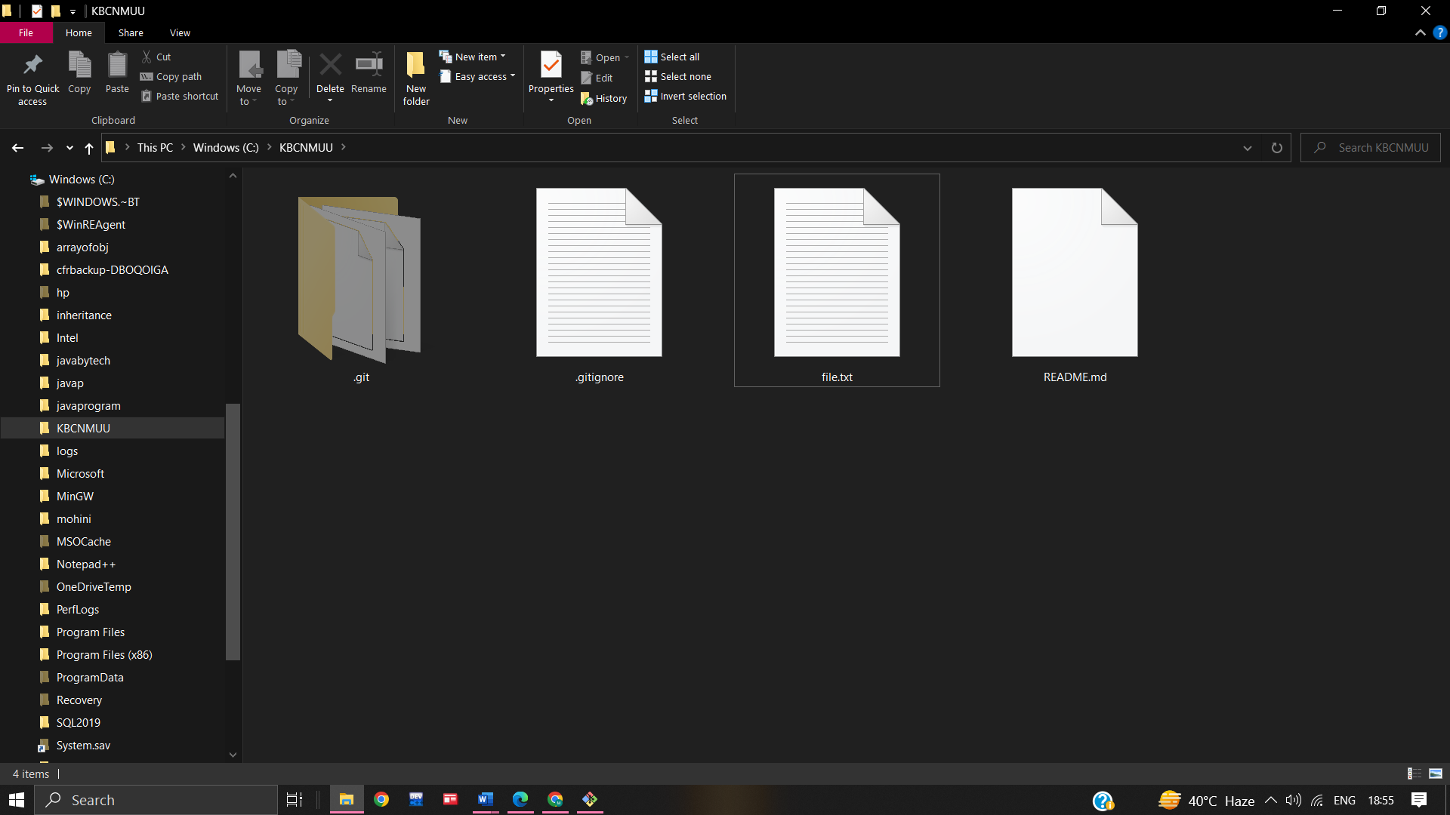

**Name :- Mohini Pramod Badhe.**

**Roll No :- 05**

**Practical :- 04**

**Practical Name :- Use git push to send your change to the primary repository. Look online to see if your change has been pushed.**

------------------------------------------------------------------------------------------------------------------------------------------------------

MOHINI@LAPTOP-J8VNJ4IR MINGW64 /c

$ git clone https://github.com/mahibadhe18/FYMCA.git

Cloning into 'FYMCA'...

remote: Enumerating objects: 3, done.

remote: Counting objects: 100% (3/3), done.

remote: Total 3 (delta 0), reused 0 (delta 0), pack-reused 0

Receiving objects: 100% (3/3), done.

MOHINI@LAPTOP-J8VNJ4IR MINGW64 /c

$ cd FYMCA

MOHINI@LAPTOP-J8VNJ4IR MINGW64 /c/FYMCA (main)

$ git init FYMCA

Initialized empty Git repository in C:/FYMCA/FYMCA/.git/

MOHINI@LAPTOP-J8VNJ4IR MINGW64 /c/FYMCA (main)

$ touch FYMCA1.txt

MOHINI@LAPTOP-J8VNJ4IR MINGW64 /c/FYMCA (main)

$ git status

On branch main

Your branch is ahead of 'origin/main' by 1 commit.

(use "git push" to publish your local commits)

Untracked files:

(use "git add <file>..." to include in what will be committed)

FYMCA/

FYMCA1.txt

nothing added to commit but untracked files present (use "git add" to track)

MOHINI@LAPTOP-J8VNJ4IR MINGW64 /c/FYMCA (main)

$ git add FYMCA1.txt

MOHINI@LAPTOP-J8VNJ4IR MINGW64 /c/FYMCA (main)

$ git commit -m "First Commit"

[main c5dfb36] First Commit

1 file changed, 0 insertions(+), 0 deletions(-)

create mode 100644 FYMCA1.txt

MOHINI@LAPTOP-J8VNJ4IR MINGW64 /c/FYMCA (main)

$ git push -u origin main

Enumerating objects: 6, done.

Counting objects: 100% (6/6), done.

Delta compression using up to 4 threads

Compressing objects: 100% (4/4), done.

Writing objects: 100% (5/5), 516 bytes | 516.00 KiB/s, done.

Total 5 (delta 0), reused 0 (delta 0), pack-reused 0

To https://github.com/mahibadhe18/FYMCA.git

fba766b..c5dfb36 main -> main

branch 'main' set up to track 'origin/main'.

**Create Repository :**

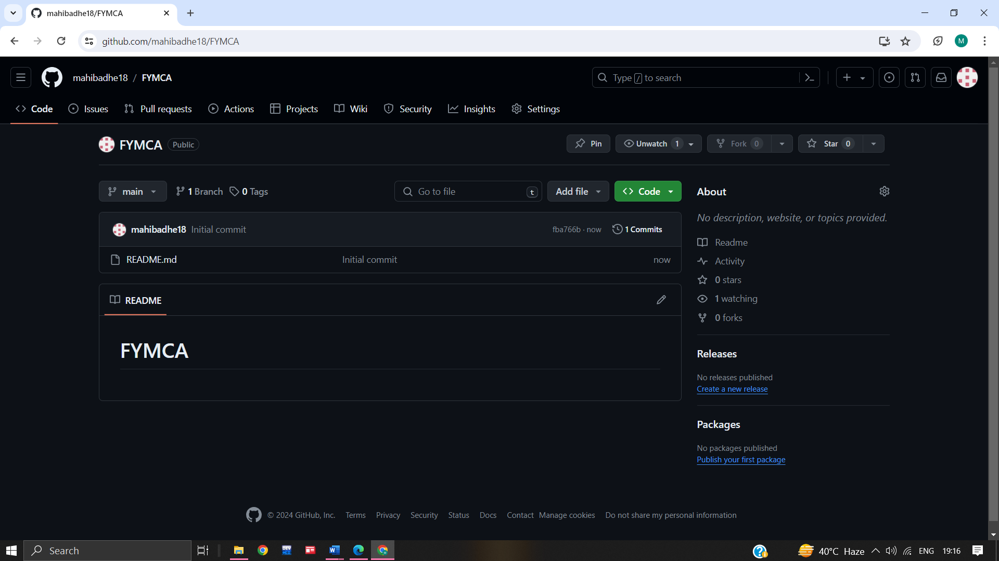

**Before Push :**

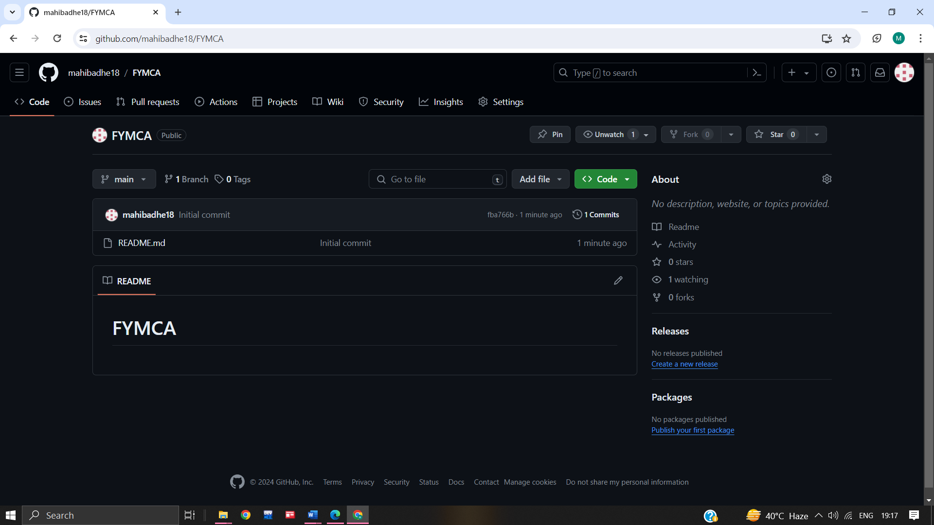

**Authentication :**

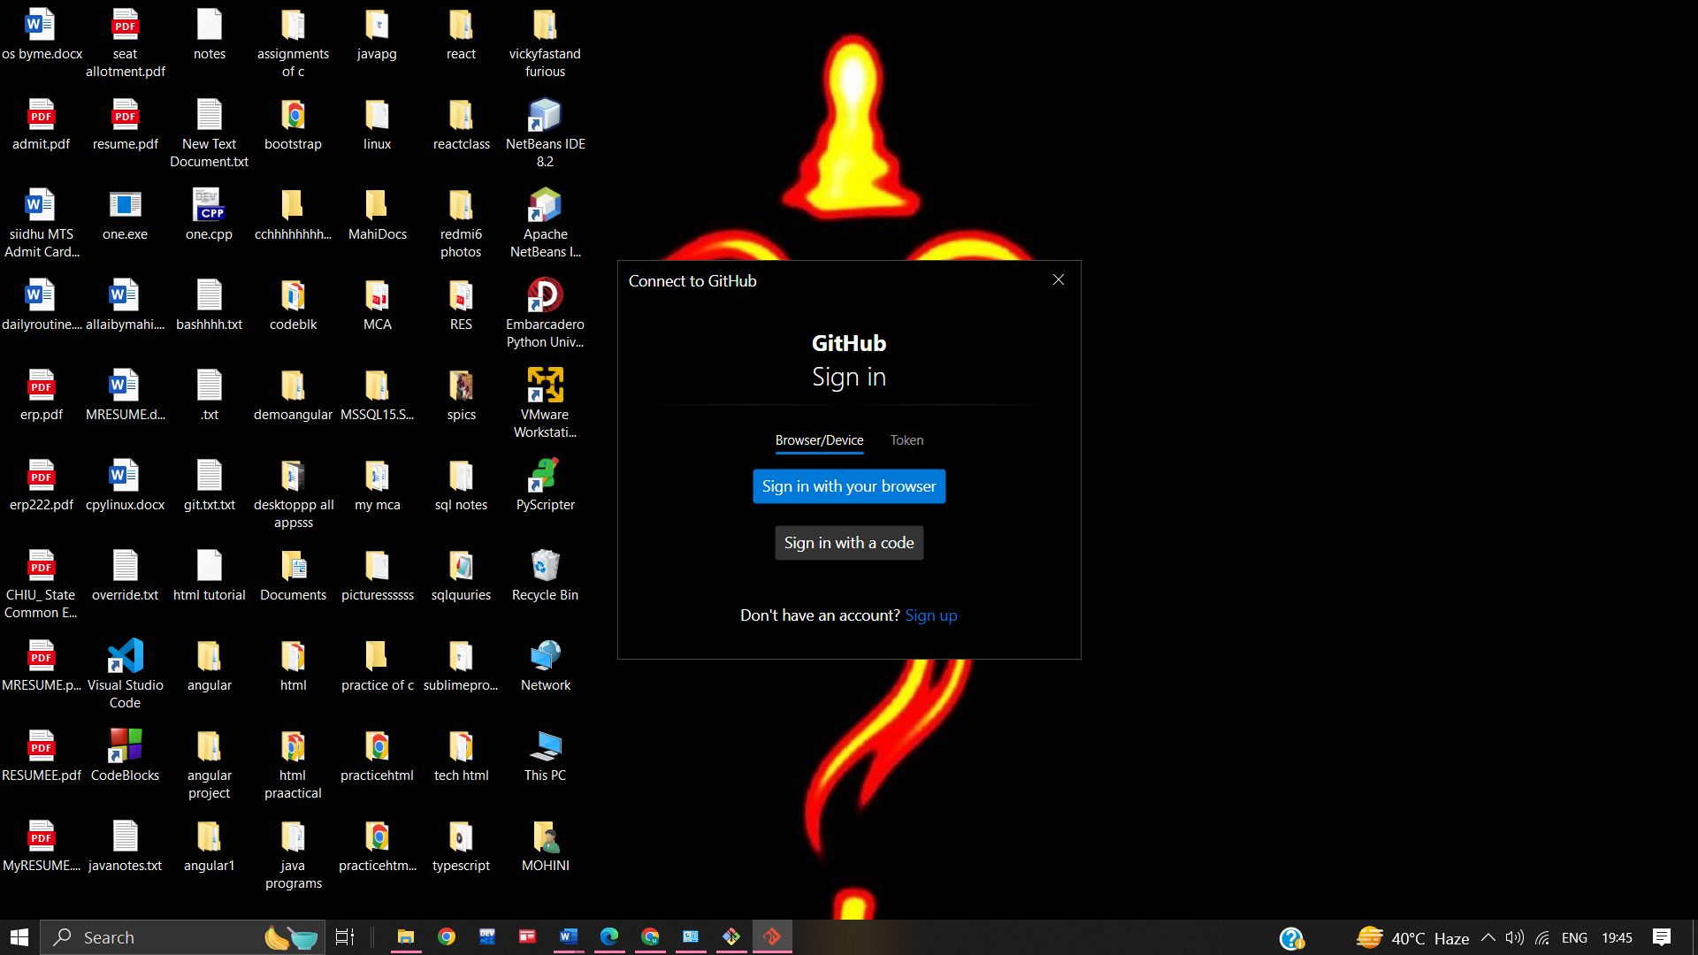

**After Push :**

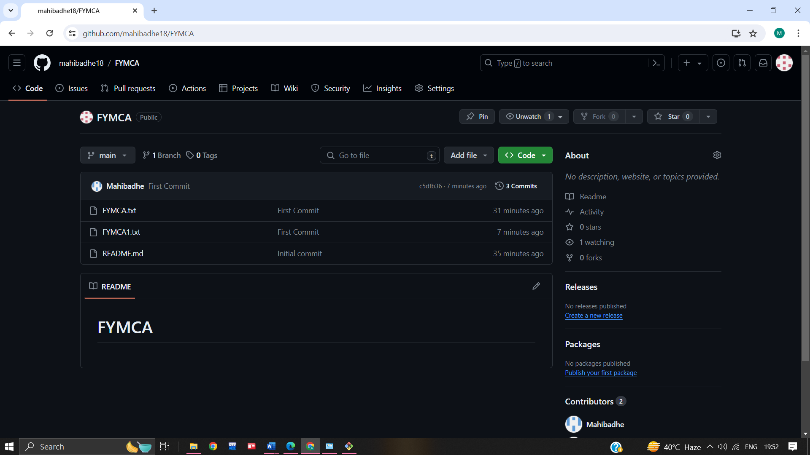

**Name :- Mohini Pramod Badhe.**

**Roll No :- 05**

**Practical :- 05**

**Practical Name :- Use git pull to get your partners change into repository. Verify that you have the new file.**

------------------------------------------------------------------------------------------------------------------------------------------------------

MOHINI@LAPTOP-J8VNJ4IR MINGW64 ~

$ mkdir git_demo

MOHINI@LAPTOP-J8VNJ4IR MINGW64 ~

$ cd git_demo

MOHINI@LAPTOP-J8VNJ4IR MINGW64 ~/git_demo

$ pwd

/c/Users/MOHINI/git_demo

MOHINI@LAPTOP-J8VNJ4IR MINGW64 ~/git_demo

$ mkdir changes

MOHINI@LAPTOP-J8VNJ4IR MINGW64 ~/git_demo

$ pwd

/c/Users/MOHINI/git_demo

MOHINI@LAPTOP-J8VNJ4IR MINGW64 ~/git_demo

$ git init

Initialized empty Git repository in C:/Users/MOHINI/git_demo/.git/

MOHINI@LAPTOP-J8VNJ4IR MINGW64 ~/git_demo (master)

$ cd changes

MOHINI@LAPTOP-J8VNJ4IR MINGW64 ~/git_demo/changes

$ pwd

/c/Users/MOHINI/git_demo/changes

MOHINI@LAPTOP-J8VNJ4IR MINGW64 ~/git_demo/changes

$ git init

Initialized empty Git repository in C:/Users/MOHINI/git_demo/changes/.git/

MOHINI@LAPTOP-J8VNJ4IR MINGW64 ~/git_demo/changes (master)

$ git pull https://github.com/mahibadhe18/KBCNMUU.git

remote: Enumerating objects: 7, done.

remote: Counting objects: 100% (7/7), done.

remote: Compressing objects: 100% (5/5), done.

remote: Total 6 (delta 1), reused 0 (delta 0), pack-reused 0

Unpacking objects: 100% (6/6), 609.21 KiB | 46.00 KiB/s, done.

From https://github.com/mahibadhe18/KBCNMUU

* branch HEAD -> FETCH_HEAD

Updating files: 100% (2/2), done.

Updating 6014129..2e2bda4

Fast-forward

alpha | 1 +

tymark.pdf | Bin 0 -> 644109 bytes

2 files changed, 1 insertion(+)

create mode 100644 alpha

create mode 100644 tymark.pdf

MOHINI@LAPTOP-J8VNJ4IR MINGW64 ~/git_demo/changes (master)

$ git status

On branch master

Changes not staged for commit:

(use "git add <file>..." to update what will be committed)

(use "git restore <file>..." to discard changes in working directory)

modified: alpha

no changes added to commit (use "git add" and/or "git commit -a")

MOHINI@LAPTOP-J8VNJ4IR MINGW64 ~/git_demo/changes (master)

$ git add .

MOHINI@LAPTOP-J8VNJ4IR MINGW64 ~/git_demo/changes (master)

$ git commit -m "changes made"

[master 0c75825] changes made

1 file changed, 1 insertion(+), 1 deletion(-)

MOHINI@LAPTOP-J8VNJ4IR MINGW64 ~/git_demo/changes (master)

$ git status

On branch master

nothing to commit, working tree clean

MOHINI@LAPTOP-J8VNJ4IR MINGW64 ~/git_demo/changes (master)

$ git remote add origin https://github.com/mahibadhe18/KBCNMUU.git

MOHINI@LAPTOP-J8VNJ4IR MINGW64 ~/git_demo/changes (master)

$ git remote -v

origin https://github.com/mahibadhe18/KBCNMUU.git (fetch)

origin https://github.com/mahibadhe18/KBCNMUU.git (push)

MOHINI@LAPTOP-J8VNJ4IR MINGW64 ~/git_demo/changes (master)

$ git push -u origin master

Enumerating objects: 5, done.

Counting objects: 100% (5/5), done.

Delta compression using up to 4 threads

Compressing objects: 100% (2/2), done.

Writing objects: 100% (3/3), 275 bytes | 275.00 KiB/s, done.

Total 3 (delta 1), reused 0 (delta 0), pack-reused 0

remote: Resolving deltas: 100% (1/1), completed with 1 local object.

remote:

remote: Create a pull request for 'master' on GitHub by visiting:

remote: https://github.com/mahibadhe18/KBCNMUU/pull/new/master

remote:

To https://github.com/mahibadhe18/KBCNMUU.git

* [new branch] master -> master

branch 'master' set up to track 'origin/master'.

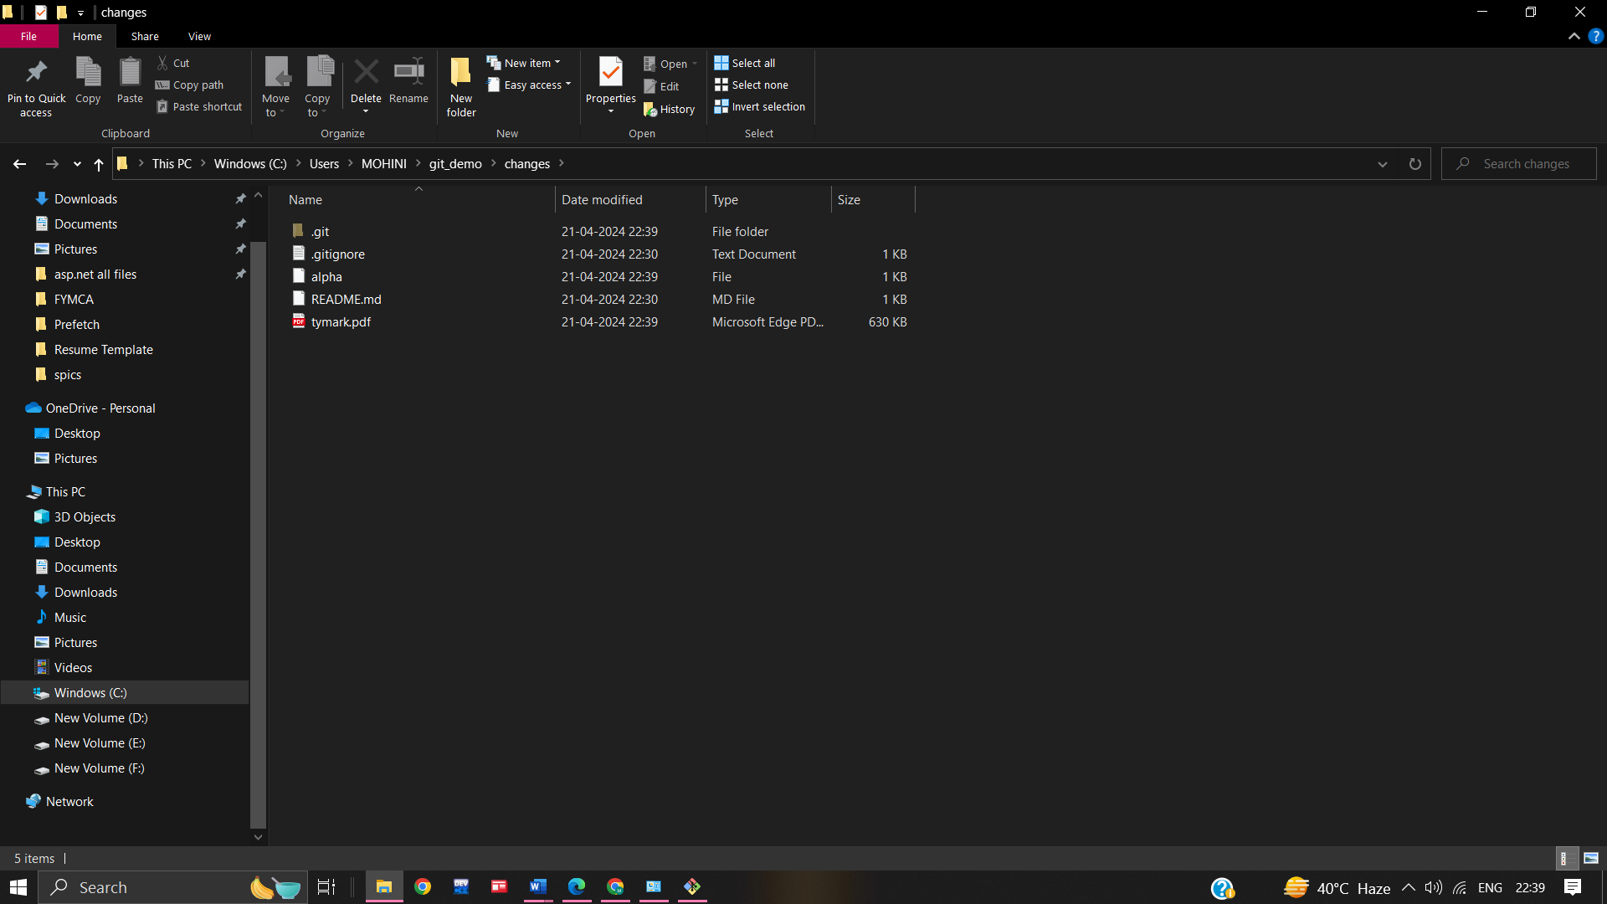

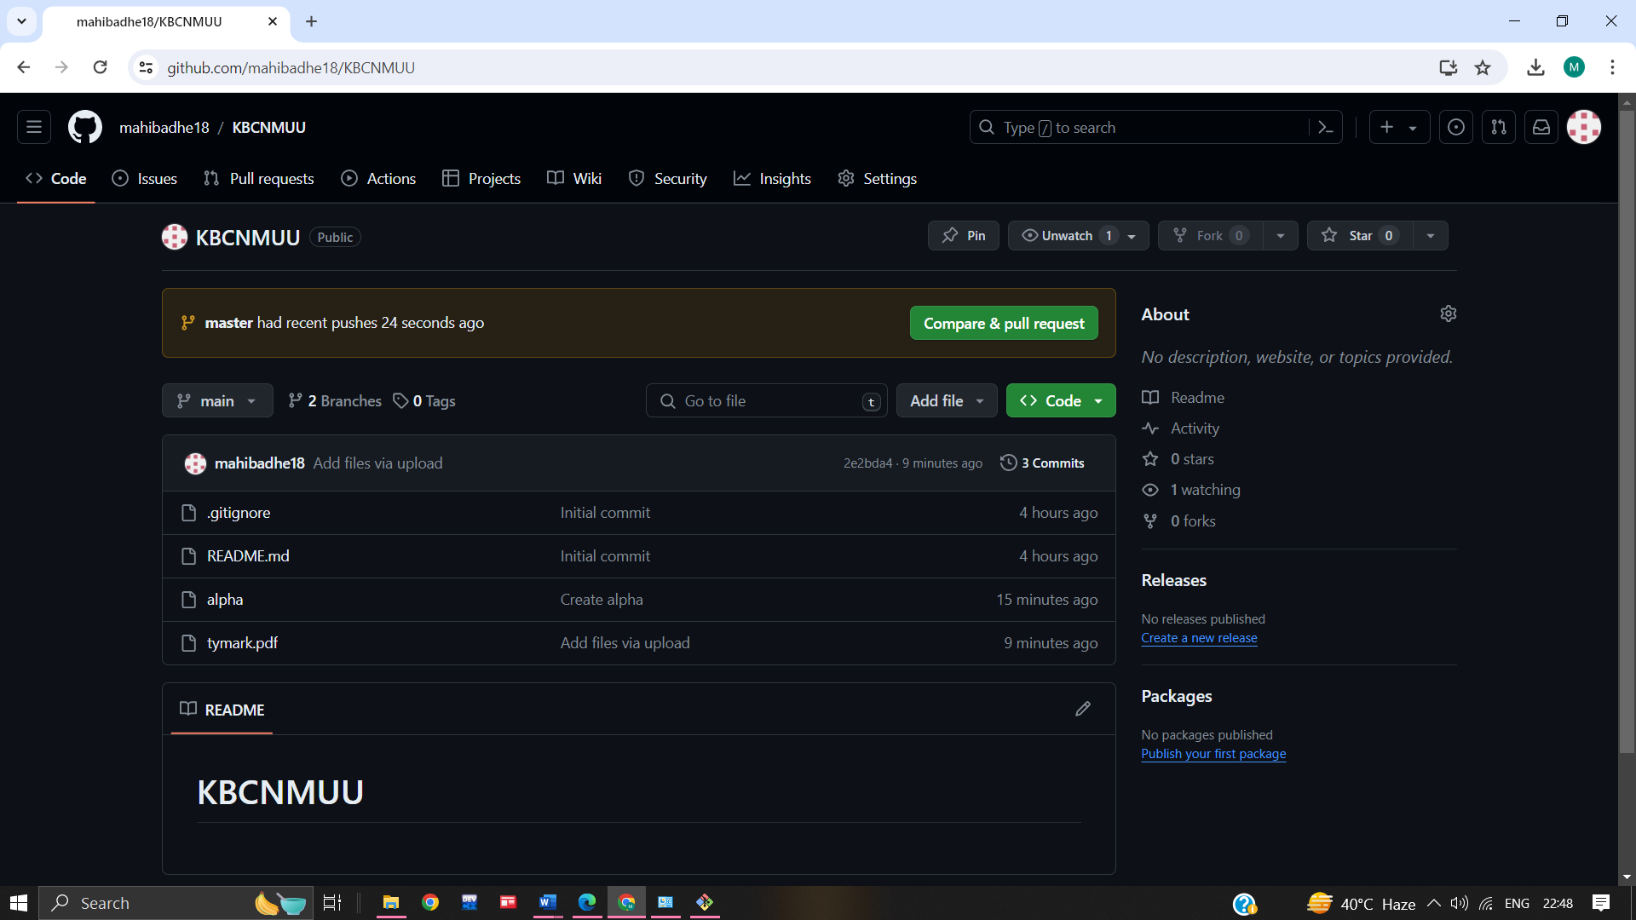

**Name :- Mohini Pramod Badhe.**

**Roll No :- 05**

**Practical :- 06**

**Practical Name :-** **Use git log or git log | less to see a list of changes to the repository.**

------------------------------------------------------------------------------------------------------------------------------------------------------

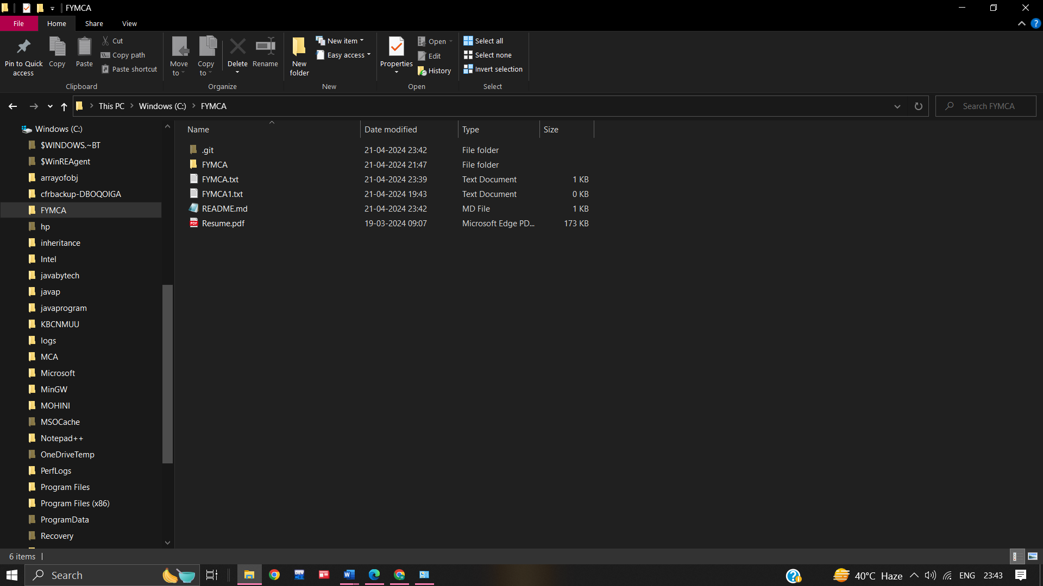

**Name :- Mohini Pramod Badhe.**

**Roll No :- 05**

**Practical :- 07**

**Practical Name :-** **Use git branch to create a new branch and git checkout to switch to the branch.**

------------------------------------------------------------------------------------------------------------------------------------------------------

**Name :- Mohini Pramod Badhe.**

**Roll No :- 05**

**Practical :- 08**

**Practical Name :-** **Use git merge to merge you changes to the primary branch.**

------------------------------------------------------------------------------------------------------------------------------------------------------

**Name :- Mohini Pramod Badhe.**

**Roll No :- 05**

**Practical :- 09**

**Practical Name :- Demonstrate the use of git diff command.**

------------------------------------------------------------------------------------------------------------------------------------------------------